Underneath the Hood of a Webmap – Mapping Cheesesteaks!
Steps to take
- Download Brackets and Google Chrome (if necessary)
- Download the HTML File (by right clicking on the file in blackboard and clicking 'save link as' – make sure to save with .html extension.
- Locate and Open The HTML File while in Brackets. You can use the 'open' function just like a word program.
When you think you have accomplished this please see the video link I have included. This will help you with these written instructions.
Rules to working inside brackets
- In the top right hand corner there is a thunderbolt – this is the live preview – this let’s you know your map is working
- Use control S or file save every time you make a change. To see the change appear please refresh your map from the live preview
- If your map doesn’t show up – you did something wrong. No problem just press control z in brackets to undo (edit – undo) and save. Please make sure your maps works after every change you make so you can go back and correct yourself. If you get frustrated re download the .html file and start over.
Task 1: Change the Title of the map to something to do with Cheesesteaks (between the h1 tags where ‘Title’ is.
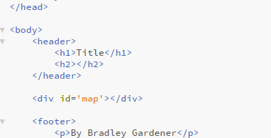
Task 2: Change the footer of the map (between the p tags to your name)
Task 3: Change the color of the text in the h1 tags under style
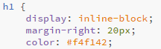
Find the colors by typing in ‘html color picker’ in google. Make sure all of the notion is correct.
Task 4: Change the color of the text in the p tags under style
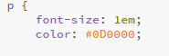
Task 5: Find the name of a cheesesteak place that is not mentioned in the array ‘var cs’. Put the name of the new cheesesteak spot in the spot where I have Oregon steaks highlighted.
This is an array – a handy way for storing data. See here for more information
Task 6: Change the latitude and longitude of the first entry in ‘var CsCoord’
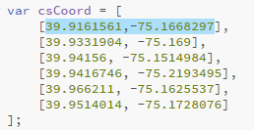
Find the lat lon of the new cheesteak place by looking it up on google maps
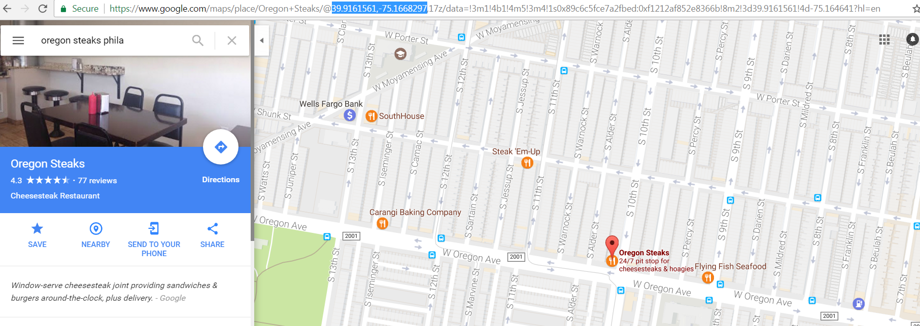
Paste the lat lon into the highlighted space (the first set of coordinates.
Task #7 and Task #8
In ‘var csStar’ replace the first entry to the right of the square brackets (3.5) with the number of starts the cheesteak place your chose has on yelp. Please look it up on Yelp to find it out
For Task #8 please find the number of reviews your cheesesteak place has on Yelp. Replace the first entry in the ‘var csReviews’ array. (89)
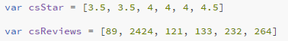

Task #9 (Just read this – don’t touch it)
These pieces of information will be combined to produce what I am calling a Yelp Factor in a function. The function multiplies the yelp stars by the number of yelp reviews. Click here for more about functions – please don’t touch the function!
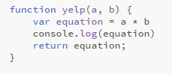
Task #10 (Just read this – don’t touch it)
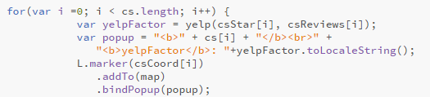
The for loop allows the computer to loop through the data structure in the code (an array) For more information go here
Please don’t touch the for loop!
Inside this for loop is also a method called .bindpopup. Find more about methods here
The popup determines what will come up when you click on the map marker. Don’t worry about this too much.
As I mentioned – we are sending a request to an external server through the internet. This ‘leaflet’ server which we have a link to in the header of our .html file then spits back the map (and it’s functionality) that we see on the screen.
This is the documentation
Question: Please browse through the documentation. What are some things you can do with Leaflet code that we didn’t do in this lab?
Final Submission – Please submit the .html file with the changes you made for tasks #1 - #8
Also, submit this document with the question at the end answered the documentation.
What Leaflet does
Basically, what Leaflet does, it works with maps with tiled base layers, panning and zooming, and feature layers that you supply. It handles various basic tasks like converting data to map layers and mouse interactions, and it's easy to extend with plugins. It will also work well across most types of devices. What Leaflet doesn’t do is provide any data for you! Leaflet is a framework for showing and interacting with map data, but it's up to you to provide that data, including a base map. Leaflet is also not GIS, although it can be combined with tools like CARTO. Leaflet works start with an empty webpage, then progressively add components to make a Leaflet map. It assumes a basic knowledge of HTML and JavaScript.

